

**CAPSTONE PROJECT 2**

**USER STORY DOCUMENT**

**WHAT SHOULD I EAT TODAY?**

**VERSION: 1.1**

**Mentor : Nguyen Thi Bao Trang**

**Project Team : 101dogS Team**

**Team Member : Le Nguyen Hoang Van**

**Lương Minh Hiếu**

**Tran Quang Khai**

**Nguyen Dinh Luu**

**03/22/2020**

**INTERNATIONAL SCHOOL OF DUYTAN UNIVERSITY**

|  |  |  |  |  |  |  |  |  |  |  |  |  |  |  |  |  |  |  |  |  |  |  |  |  |  |  |  |  |  |  |  |  |  |  |  |  |  |  |  |  |  |  |  |  |  |  |  |  |  |  |  |  |  |  |  |  |  |  |  |  |  |
| --- | --- | --- | --- | --- | --- | --- | --- | --- | --- | --- | --- | --- | --- | --- | --- | --- | --- | --- | --- | --- | --- | --- | --- | --- | --- | --- | --- | --- | --- | --- | --- | --- | --- | --- | --- | --- | --- | --- | --- | --- | --- | --- | --- | --- | --- | --- | --- | --- | --- | --- | --- | --- | --- | --- | --- | --- | --- | --- | --- | --- | --- |
| **PROJECT INFORMATION**   |  |  |  |  |  | | --- | --- | --- | --- | --- | |  | **PROJECT INFORMATION** | | | | | **Project Acronym** | WIET | | | | | **Project Title** | What should I eat today? | | | | | **Start Date** | 02/12/2020 | **End Date** | 05/15/2020 | | | **Lead Institution** | International School, Duy Tan University | | | | | **Project Mentor** | Nguyen Thi Bao Trang | | | | | **Product Owner & Contact Detail** | Le Nguyen Hoang Van | | | | | **Partner Organization** |  | | | | | **Scrum Master** | Le Nguyen Hoang Van | lenguyenhoangvan18@gmail.com | | 0935604934 | | **Team Members** | Luong Minh Hieu | Minhhieu98@gmail.com | | 0399870055 | | Nguyen Dinh Luu | dinhluu098@gmail.com | | 0935883503 | | Tran Quang Khai | tquangkhai98@gmail.com | | 0976308098 |   **USER STORY DOCUMENT** | | | |
| **Document Title** | User Story Document | | |
| **Author(s)** | 101dogS Team | | |
| **Role** | Product Owner, Team Member, Scrum Master | | |
| **Date** | 03/22/2020 | **File name:** | UserStory-Caps2-101dogS-ver1.1 |
| **URL** |  | | |
| **Access** | Project and CMU Program | | |

**REVISION HISTORY**

|  |  |  |  |
| --- | --- | --- | --- |
| **Version** | **Person(s)** | **Date** | **Description** |
| **1.0** | Luong Minh Hieu | 03/22/2020 | Create User story Document for project |
| **1.1** | Le Nguyen Hoang Van | 04/23/2020 | Update User story Document for project |

|  |  |  |  |
| --- | --- | --- | --- |
| **Document Approval**  The following signatures are required for approval of this document | | | |
| **Mentor** | Nguyen Thi Bao Trang | **Signature:** |  |
| **Date:** |  |
| **Product owner** | Le Nguyen Hoang Van | **Signature:** |  |
| **Date:** |  |
| **Scrum master** | Le Nguyen Hoang Van | **Signature:** |  |
| **Date:** |  |
| **Team member(s)** | Nguyen Dinh Luu | **Signature:** |  |
| **Date:** |  |
| Tran Quang Khai | **Signature:** |  |
| **Date:** |  |
| Luong Minh Hieu | **Signature:** |  |
| **Date:** |  |

**Contents**

**1.** **Introduction** 6

**1.1.** **Document Overview** 6

**1.2.** **Business Needs and User Needs** 6

**2.** **Use Case of “Swimming Go” System** 7

**3.** **User Story of “WIET”** 8

**3.1.** **US01 – Log in** 8

**3.2.** **US02 – Log out** 8

**3.3.** **US03 – Edit profile** 8

**3.4.** **US04 - Recommend** 9

**3.5.** **US05 – Recommend by Weather** 9

**3.6.** **US06 – Recommend by day session** 10

**3.7.** **US07 – Search Dishes** 10

**3.8.** **US08 – Detail foods** 11

**3.9.** **US09 – Bookmark** 11

**3.10.** **US10 – Show history recommendations** 11

**3.11.** **US11 – Sent recommend via messenger** 12

1. **Introduction**

In the field of software development, User Story (User Stories) is one or more sentences describing natural language (not technical language) or business language of the end user or system user to record what the user needs to do or not to do as part of their job or task. User stories are used in methods like Agile software development is the basis for determining the functions of the system are business development and create favorable conditions for requirements management. Help yourself to know the “who”, “what” and “why” in a simple request, short, often only limited by what details can be written on a piece of paper notes, small scrap paper.

User story is written by business users as the primary way users because they understand most of the process, work flow and functionality of the system should be working now. User story can also be written by developer to express non-functional requirements (such as security, performance, quality)

* 1. **Document Overview**
* This document provides a user story and goal-oriented view of the “Swimming Go” project which delivers several key project benefits below:
* It helps answer the question “What does this project do?” for the business, project sponsors, developers and architects including clearly defining scope.
* It supports to define target and future state architectures.
* It helps understand required capabilities to support a project.
* It provides a meaningful resource which can be used in conversation between the business and architecture team.
  1. **Business Needs and User Needs**

**Business needs:**

**User needs:**

When the coaches use out application, it can help:

* Give recommend what to eat at the moment and the location is nearby.
* Give recommend what should to eat in this weather.
* Eliminate allergies in recommend.
* Minimize time for finding food.

1. **Use Case of “WIET” System**

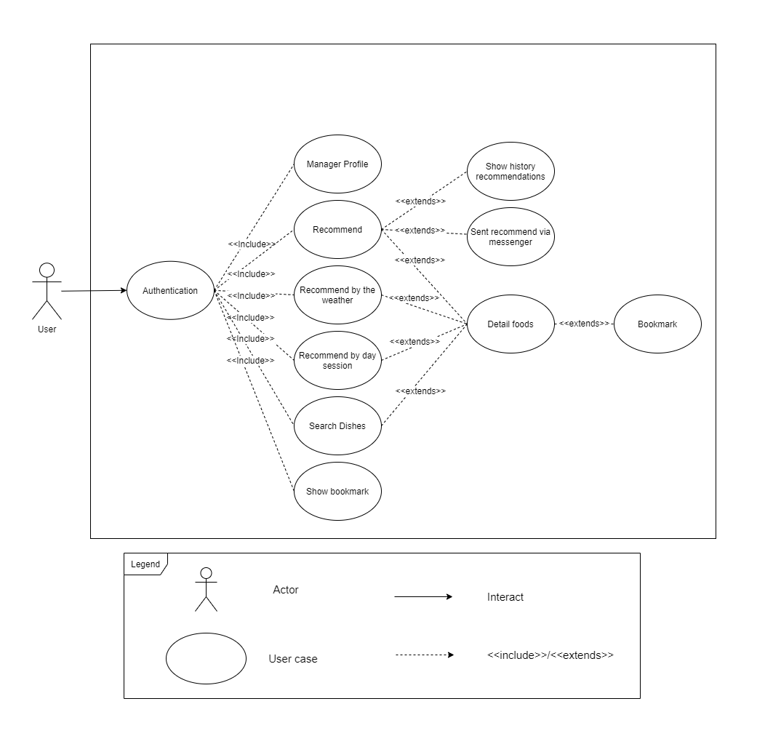

1. **User Story of “WIET”**
   1. **US01 – Log in**

|  |  |
| --- | --- |
| **As a User**  **I want to** login with Facebook account or google account **so that** I can use the App. | |
| **Login** | **Project:** WIET |
| **Actor:** Coach | **Date:** 03/22/2020 |
| **Story:** User want to access the WIET application by Facebook or Google account. | **Acceptance Criteria**  - User can login into system by Facebook account when User click on [Facebook Login] button.  User can login into system by Google account when User click on [Google Login] button.  - Generate failure or success messages when processing.  - Show the error messages when value is invalid. |

* 1. **US02 – Log out**

|  |  |
| --- | --- |
| **As a** **Coach**  **I want to** logout system **so that** I can stop using application when I click on Logout button and I can login later. | |
| **Logout** | **Project:** WIET |
| **Actor:** User | **Date:** 03/22/2020 |
| **Story:** User want to logout the application. | **Acceptance Criteria**  - Coach can logout system when coach click on [Đăng xuất] button. |

* 1. **US03 – Edit profile**

|  |  |
| --- | --- |
| **As a** **User**  **I want to** edit my profile **so that** I can change my information. | |
| **Edit profile** | **Project:** WIET |
| **Actor:** User | **Date:** 03/22/2020 |
| **Story:** User want to change their information | **Acceptance Criteria**  - User edit their profile by clicking on [More function] button on the bottom right screen, after that, Click on [Profile] button and input value on relevant field.  - User update successfully when inputting correctly value on fields and click [Lưu thay đổi] button.  - Generate failure or success messages when processing.  - Show the error messages when value is invalid. |

* 1. **US04 - Recommend**

|  |  |
| --- | --- |
| **As a** **User**  **I want to** know what should I eat today, **so that** I use this application to get recommendation. | |
| **Recommend** | **Project:** WIET |
| **Actor:** User | **Date:** 03/22/2020 |
| **Story:** User want to know What should they eat today. | **Acceptance Criteria**  - User have to login into application.  - User successfully login by Facebook or google accounts.  - In the fist time login, User input some private information and click on [Xác nhận] button.  -User get Recommendation on main screen after login successful.  - Generate failure or success messages when processing.  - Show the error messages when value is invalid. |

* 1. **US05 – Recommend by Weather**

|  |  |
| --- | --- |
| **As a** **User**  **I want to** know what should I eat today on this weather, **so that** I use this application to get recommendation. | |
| **Recommend by Weather** | **Project:** WIET |
| **Actor:** User | **Date:** 03/22/2020 |
| **Story:** User want to know What should they eat today on this weather. | **Acceptance Criteria**  - User have to login into application.  - User successfully login by Facebook or google accounts.  - In the fist time login, User input some private information and click on [Xác nhận] button.  -User get Recommendation by click on “meals today” after login successful.  - Generate failure or success messages when processing.  - Show the error messages when value is invalid. |

* 1. **US06 – Recommend by day session**

|  |  |
| --- | --- |
| **As a** **User**  **I want to** know what should I eat today by day session, **so that** I use this application to get recommendation. | |
| **Recommend by day session** | **Project:** WIET |
| **Actor:** User | **Date:** 03/22/2020 |
| **Story:** User want to know What should they eat today by day session. | **Acceptance Criteria**  - User have to login into application.  - User successfully login by Facebook or google accounts.  - In the fist time login, User input some private information and click on [Xác nhận] button.  -User get Recommendation by click on “meals today” after login successful.  - Generate failure or success messages when processing.  - Show the error messages when value is invalid. |

* 1. **US07 – Search Dishes**

|  |  |
| --- | --- |
| **As a** **User**  **I want to** search food names, **so that** I can input and search that. | |
| **Search Dishes** | **Project:** WIET |
| **Actor:** User | **Date:** 03/22/2020 |
| **Story:** User want to search name of dishes. | **Acceptance Criteria**  - User have to login into application.  - User click on “search foods” on main screen.  -I Fill food name on search bar and the application give result.  -If the food name has gave user the list of dishes else give message “Không có tên món ăn này”  - Generate failure or success messages when processing.  - Show the error messages when value is invalid. |

* 1. **US08 – Detail foods**

|  |  |
| --- | --- |
| **As a** **User** | |
| **I want to** know the location nearby of foods, price and more; **so that** I can see it on detail. | |
| **Detail foods** | **Project:** WIET |
| **Actor:** User | **Date:** 03/22/2020 |
| **Story:** User want to detail foods. | **Acceptance Criteria**  - User have to login into application.  - After the operations are “search dishes”, “recommendation”, etc  -Click on “Like” icon button, the application will show the detail of foods.  - Generate failure or success messages when processing.  - Show the error messages when value is invalid |

* 1. **US09 – Bookmark**

|  |  |
| --- | --- |
| **As a User**  **I want to** remove my team members **so that** I can remove swimmer no longer in my team. | |
| **Bookmark** | **Project:** WIET |
| **Actor:** User | **Date:** 03/22/2020 |
| **Story:** User want to bookmark after recommend. | **Acceptance Criteria**  - User have to login into application.  - After the operations are “search dishes”, “recommendation”, etc  -On food detail screen, Click on “Bookmark” icon button.  - At main screen, click on “More Function” button and click on “Bookmark” to show list bookmark saved.  - Generate failure or success messages when processing.  - Show the error messages when value is invalid. |

* 1. **US10 – Show history recommendations**

|  |  |
| --- | --- |
| **As a** **User**  **I want to** create exercise, **so that** I can manage my exercise easier. | |
| **Show history recommendations** | **Project:** WIET |
| **Actor:** User | **Date:** 03/22/2020 |
| **Story:** User want to show history recomendations | **Acceptance Criteria**  - User have to login into application.  - After the recommendation operation and choose the dishes you like.  - At main screen, click on “More Function” button and click on “Lịch sử gợi ý” to show list history recommendations.  - Generate failure or success messages when processing.  - Show the error messages when value is invalid. |

* 1. **US11 – Sent recommend via messenger**

|  |  |
| --- | --- |
| **As a** **User**  **I want to** get recommendation without login the application, **so that** I get a message. | |
| **Sent recommend via messenger** | **Project:** WIET |
| **Actor:** User | **Date:** 03/22/2020 |
| **Story:** User want to get recommendations by message. | **Acceptance Criteria**  - Users edit their profile by clicking on [More function] button on the bottom right screen, after that, click on [Function setting] button and Choose “sent recommend via messenger” field.  - User update successfully when inputting correctly value on fields and click [Lưu thay đổi] button.  - Generate failure or success messages when processing.  - Show the error messages when value is invalid. |